Supplementary material
(Appendix A– Appendix K)

Appendix A: Data description (meteorological indicators and thermal comfort indices) 2
Appendix B: Data description (Indicators of the routine daily cycle of human activities) 4
Appendix C: Sample size 5
Appendix D: Algorithm performance comparison by RMSPE and R² 6
Appendix E: The MARS model and the model-building process 7
Appendix F: Observed and predicted hourly electricity demand 9
Appendix G: Results of cross-fiscal year validation 10
Appendix H: Hourly simulation results for all regions and algorithms 12
Appendix I: Hourly changes in the BPT 13
Appendix J: Seasonal impacts that cannot be explained by meteorological factors. 16
Appendix K: Daytime and nighttime TRFs 17

Appendix A: Data description (meteorological indicators and thermal comfort indices)
The values of the meteorological indicators and thermal comfort indices in each region are summarized in Table A.1. and Table A.2., respectively.

Table A.1. Descriptions of the meteorological indicators.
TEMP | 1. Hokkaido | 2. Tohoku | 3. Hokuriku | 4. Tokyo | 5. Chubu | 6. Kansai | 7. Chugoku | 8. Shikoku | 9. Kyushu | 10. Okinawa
min | -14.00 | -6.30 | -3.50 | -3.60 | -3.60 | -2.10 | -4.20 | -2.30 | -1.80 | 9.50
qu.1st | 0.60 | 5.80 | 8.00 | 9.50 | 9.30 | 10.10 | 9.70 | 10.40 | 11.10 | 20.30
median | 10.20 | 14.10 | 16.00 | 17.10 | 17.40 | 18.00 | 17.60 | 17.90 | 18.50 | 24.30
qu.3rd | 18.10 | 20.80 | 23.10 | 23.30 | 24.40 | 24.80 | 24.50 | 24.40 | 24.70 | 27.90
max | 34.70 | 36.20 | 37.30 | 37.40 | 40.20 | 37.50 | 37.00 | 37.20 | 37.20 | 34.50
mean | 9.65 | 13.64 | 15.77 | 16.60 | 16.93 | 17.62 | 17.18 | 17.46 | 18.09 | 23.96
sd | 9.89 | 8.65 | 8.85 | 8.26 | 8.88 | 8.58 | 8.71 | 8.36 | 8.10 | 4.73
HUM | 1. Hokkaido | 2. Tohoku | 3. Hokuriku | 4. Tokyo | 5. Chubu | 6. Kansai | 7. Chugoku | 8. Shikoku | 9. Kyushu | 10. Okinawa
min | 8 | 12 | 8 | 16 | 7 | 14 | 10 | 12 | 14 | 28
qu.1st | 57 | 57 | 58 | 54 | 50 | 54 | 51 | 57 | 59 | 65
median | 69 | 72 | 70 | 71 | 64 | 65 | 64 | 69 | 70 | 76
qu.3rd | 80 | 85 | 80 | 86 | 78 | 77 | 75 | 81 | 82 | 85
max | 100 | 100 | 96 | 100 | 100 | 100 | 100 | 100 | 100 | 100
mean | 68 | 70 | 69 | 70 | 64 | 65 | 63 | 69 | 70 | 74
sd | 16 | 18 | 15 | 20 | 19 | 16 | 16 | 16 | 15 | 13
SUN | 1. Hokkaido | 2. Tohoku | 3. Hokuriku | 4. Tokyo | 5. Chubu | 6. Kansai | 7. Chugoku | 8. Shikoku | 9. Kyushu | 10. Okinawa
min | 0.000 | 0.000 | 0.000 | 0.000 | 0.000 | 0.000 | 0.000 | 0.000 | 0.000 | 0.000
qu.1st | 0.000 | 0.000 | 0.000 | 0.000 | 0.000 | 0.000 | 0.000 | 0.000 | 0.000 | 0.000
median | 0.020 | 0.020 | 0.020 | 0.020 | 0.020 | 0.020 | 0.020 | 0.020 | 0.020 | 0.020
qu.3rd | 0.780 | 0.800 | 0.800 | 0.860 | 1.000 | 0.960 | 0.940 | 0.930 | 0.870 | 1.010
max | 4.090 | 3.980 | 4.030 | 3.710 | 3.780 | 3.930 | 3.660 | 3.930 | 3.920 | 3.840
mean | 0.528 | 0.544 | 0.545 | 0.555 | 0.611 | 0.603 | 0.593 | 0.595 | 0.583 | 0.620
sd | 0.832 | 0.858 | 0.864 | 0.863 | 0.917 | 0.912 | 0.907 | 0.915 | 0.919 | 0.928
sum | 18,091.430 | 18,666.410 | 18,714.290 | 19,017.850 | 20,956.490 | 20,681.500 | 20,357.620 | 20,408.000 | 19,991.400 | 21,283.070
WIND1 | 1. Hokkaido | 2. Tohoku | 3. Hokuriku | 4. Tokyo | 5. Chubu | 6. Kansai | 7. Chugoku | 8. Shikoku | 9. Kyushu | 10. Okinawa
min | 0.0 | 0.0 | 0.0 | 0.0 | 0.0 | 0.0 | 0.0 | 0.0 | 0.0 | 0.0
qu.1st | 1.7 | 1.7 | 2.1 | 1.8 | 1.7 | 1.4 | 2.0 | 1.3 | 1.4 | 3.5
median | 3.0 | 2.7 | 3.4 | 2.6 | 2.6 | 2.2 | 3.1 | 2.0 | 2.3 | 4.8
qu.3rd | 4.7 | 4.0 | 5.1 | 3.6 | 4.0 | 3.2 | 4.3 | 2.8 | 3.8 | 6.5
max | 17.3 | 17.5 | 24.9 | 15.4 | 19.0 | 20.9 | 15.3 | 13.9 | 16.5 | 31.5
mean | 3.4 | 3.0 | 3.9 | 2.9 | 3.0 | 2.4 | 3.2 | 2.2 | 2.8 | 5.1
sd | 2.2 | 1.8 | 2.4 | 1.5 | 1.8 | 1.3 | 1.7 | 1.2 | 1.8 | 2.4
RAIN | 1. Hokkaido | 2. Tohoku | 3. Hokuriku | 4. Tokyo | 5. Chubu | 6. Kansai | 7. Chugoku | 8. Shikoku | 9. Kyushu | 10. Okinawa
min | 0 | 0 | 0 | 0 | 0 | 0 | 0 | 0 | 0 | 0
qu.1st | 0 | 0 | 0 | 0 | 0 | 0 | 0 | 0 | 0 | 0
median | 0 | 0 | 0 | 0 | 0 | 0 | 0 | 0 | 0 | 0
qu.3rd | 0 | 0 | 0 | 0 | 0 | 0 | 0 | 0 | 0 | 0
max | 26 | 59 | 61 | 40 | 54 | 40 | 53 | 40 | 38 | 57
mean | 0 | 0 | 0 | 0 | 0 | 0 | 0 | 0 | 0 | 0
sd | 1 | 1 | 1 | 1 | 1 | 1 | 1 | 1 | 1 | 2
sum | 4,555 | 5,054 | 9,667 | 6,359 | 6,478 | 5,486 | 6,923 | 5,959 | 6,915 | 8,817

Table A.1. Descriptions of the meteorological indicators (continued).
SNOW1 | 1. Hokkaido | 2. Tohoku | 3. Hokuriku | 4. Tokyo | 5. Chubu | 6. Kansai | 7. Chugoku | 8. Shikoku | 9. Kyushu | 10. Okinawa
min | 0 | 0 | 0 | 0 | 0 | 0 | 0 | 0 | 0 | 0
qu.1st | 0 | 0 | 0 | 0 | 0 | 0 | 0 | 0 | 0 | 0
median | 0 | 0 | 0 | 0 | 0 | 0 | 0 | 0 | 0 | 0
qu.3rd | 0 | 0 | 0 | 0 | 0 | 0 | 0 | 0 | 0 | 0
max | 11 | 5 | 8 | 4 | 5 | 0 | 5 | 0 | 3 | 0
mean | 0 | 0 | 0 | 0 | 0 | 0 | 0 | 0 | 0 | 0
sd | 0 | 0 | 0 | 0 | 0 | 0 | 0 | 0 | 0 | 0
sum | 1,670 | 136 | 464 | 24 | 19 | 0 | 22 | 0 | 7 | 0
SNOW2 | 1. Hokkaido | 2. Tohoku | 3. Hokuriku | 4. Tokyo | 5. Chubu | 6. Kansai | 7. Chugoku | 8. Shikoku | 9. Kyushu | 10. Okinawa
min | 0 | 0 | 0 | 0 | 0 | 0 | 0 | 0 | 0 | 0
qu.1st | 0 | 0 | 0 | 0 | 0 | 0 | 0 | 0 | 0 | 0
median | 0 | 0 | 0 | 0 | 0 | 0 | 0 | 0 | 0 | 0
qu.3rd | 14 | 0 | 0 | 0 | 0 | 0 | 0 | 0 | 0 | 0
max | 96 | 19 | 87 | 23 | 5 | 0 | 19 | 0 | 3 | 0
mean | 13 | 0 | 1 | 0 | 0 | 0 | 0 | 0 | 0 | 0
sd | 24 | 1 | 6 | 1 | 0 | 0 | 0 | 0 | 0 | 0
sum | 457,663 | 3,811 | 30,781 | 1,209 | 101 | 0 | 217 | 0 | 35 | 0

Table A.2. Descriptions of the thermal comfort indices.
DI | 1. Hokkaido | 2. Tohoku | 3. Hokuriku | 4. Tokyo | 5. Chubu | 6. Kansai | 7. Chugoku | 8. Shikoku | 9. Kyushu | 10. Okinawa
min | 15 | 24 | 28 | 31 | 28 | 33 | 30 | 32 | 31 | 50
qu.1st | 38 | 46 | 49 | 51 | 51 | 52 | 51 | 52 | 53 | 67
median | 52 | 58 | 60 | 62 | 62 | 63 | 63 | 63 | 64 | 74
qu.3rd | 64 | 68 | 71 | 72 | 73 | 73 | 72 | 73 | 74 | 80
max | 84 | 86 | 87 | 88 | 87 | 87 | 86 | 87 | 88 | 87
mean | 51 | 57 | 60 | 62 | 62 | 63 | 62 | 63 | 64 | 73
sd | 15 | 13 | 13 | 12 | 13 | 12 | 12 | 12 | 12 | 8
WCI | 1. Hokkaido | 2. Tohoku | 3. Hokuriku | 4. Tokyo | 5. Chubu | 6. Kansai | 7. Chugoku | 8. Shikoku | 9. Kyushu | 10. Okinawa
min | -44 | -87 | -140 | -115 | -196 | -114 | -111 | -99 | -111 | -41
qu.1st | 358 | 283 | 238 | 229 | 201 | 185 | 201 | 188 | 188 | 136
median | 555 | 448 | 424 | 379 | 367 | 339 | 374 | 333 | 333 | 235
qu.3rd | 773 | 651 | 632 | 546 | 568 | 510 | 570 | 503 | 499 | 343
max | 1,375 | 1,096 | 1,172 | 968 | 1,056 | 945 | 1,056 | 968 | 1,039 | 687
mean | 570 | 467 | 439 | 389 | 386 | 349 | 390 | 349 | 348 | 247
sd | 251 | 221 | 240 | 197 | 221 | 197 | 224 | 195 | 198 | 133
DPT | 1. Hokkaido | 2. Tohoku | 3. Hokuriku | 4. Tokyo | 5. Chubu | 6. Kansai | 7. Chugoku | 8. Shikoku | 9. Kyushu | 10. Okinawa
min | -22 | -15 | -18 | -17 | -16 | -14 | -14 | -14 | -13 | -1
qu.1st | -5 | -1 | 2 | 2 | 1 | 2 | 2 | 3 | 4 | 14
median | 3 | 8 | 9 | 12 | 10 | 11 | 9 | 11 | 13 | 20
qu.3rd | 12 | 17 | 18 | 19 | 18 | 19 | 18 | 20 | 20 | 24
max | 24 | 27 | 27 | 28 | 26 | 27 | 26 | 27 | 29 | 28
mean | 4 | 8 | 10 | 10 | 9 | 11 | 9 | 11 | 12 | 19
sd | 10 | 10 | 9 | 10 | 10 | 9 | 9 | 9 | 9 | 6

Appendix B: Data description (Indicators of the routine daily cycle of human activities)
Indicators of the routine daily cycle of human activities are visualized in Fig. B.1.
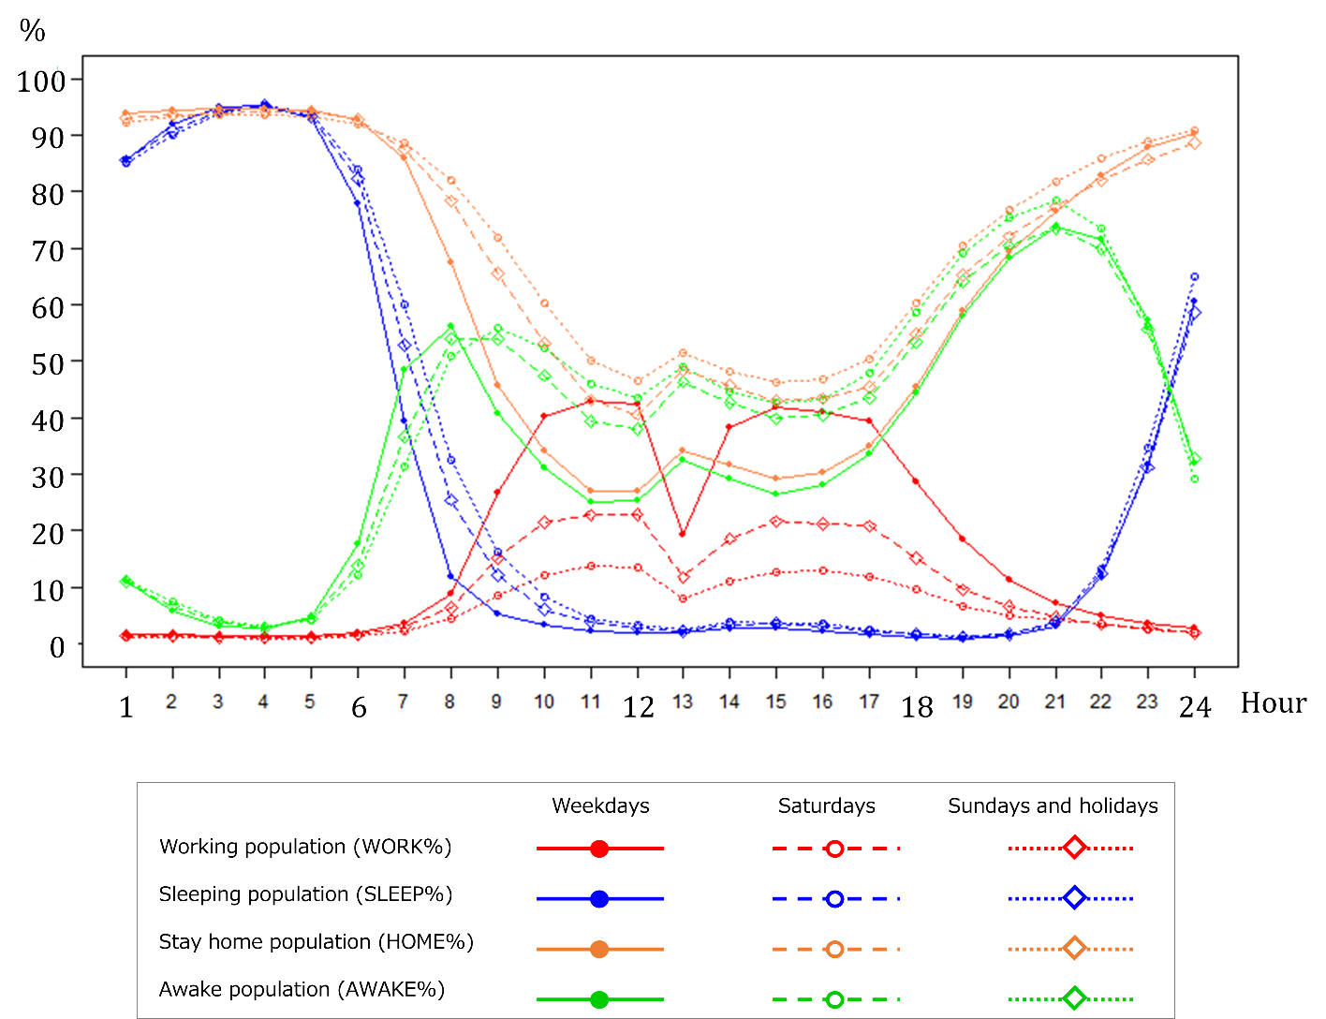
Fig. B.1. Variables representing the routine daily cycle of human activities
(data source: NHK Broadcasting Culture Research Institute, 2015).

Appendix C: Sample size
Table C.1 presents the sample sizes by fiscal year and region. Outliers in electricity demand data were detected by using the Smirnov–Grubbs test, which was repeatedly applied to the data. As a result, 40 observations in Hokkaido were omitted. In addition, hourly observations with at least one missing variable in a one-hour time window were also omitted. The smallest sample size was 8,722 out of 8,760 (99.57%, Tokyo, FY2017). Therefore, at least 99% of all samples were secured for all datasets. However, because the solar radiation (SUN) data at the Kanazawa weather station were missing throughout the survey period, we used observational data from the Fukui station, which is also located in Hokuriku region.

Table C.1. Sample size of the dataset for each EPC and each fiscal year.
 | Region | Weather station | FY2016 (%) |  | FY2017 (%) |  | FY2018 (%)
1 | Hokkaido | Sapporo | 8,750 | (99.89) | 8,759 | (99.99) | 8,711 | (99.44)
2 | Tohoku | Sendai | 8,758 | (99.98) | 8,756 | (99.95) | 8,752 | (99.91)
3 | Tokyo | Tokyo | 8,747 | (99.85) | 8,722 | (99.57) | 8,748 | (99.86)
4 | Chubu | Nagoya | 8,756 | (99.95) | 8,760 | (100.00) | 8,756 | (99.95)
5 | Hokuriku | Kanazawa | 8,757 | (99.97) | 8,758 | (99.98) | 8,757 | (99.97)
6 | Kansai | Osaka | 8,760 | (100.00) | 8,758 | (99.98) | 8,756 | (99.95)
7 | Chugoku | Hiroshima | 8,759 | (99.99) | 8,755 | (99.94) | 8,759 | (99.99)
8 | Shikoku | Matsuyama | 8,753 | (99.92) | 8,732 | (99.68) | 8,754 | (99.93)
9 | Kyushu | Fukuoka | 8,757 | (99.97) | 8,758 | (99.98) | 8,759 | (99.99)
10 | Okinawa | Naha | 8,760 | (100.00) | 8,759 | (99.99) | 8,759 | (99.99)
Minimum |  |  | 8,747 | (99.85) | 8,722 | (99.57) | 8,711 | (99.44)
Maximum |  |  | 8,760 | (100.00) | 8,760 | (100.00) | 8,759 | (99.99)
Average |  |  | 8,756 | (99.95) | 8,752 | (99.91) | 8,751 | (99.90)
Total |  |  | 87,557 | (99.95) | 87,517 | (99.91) | 87,511 | (99.90)

Appendix D: Algorithm performance comparison by RMSPE and R²

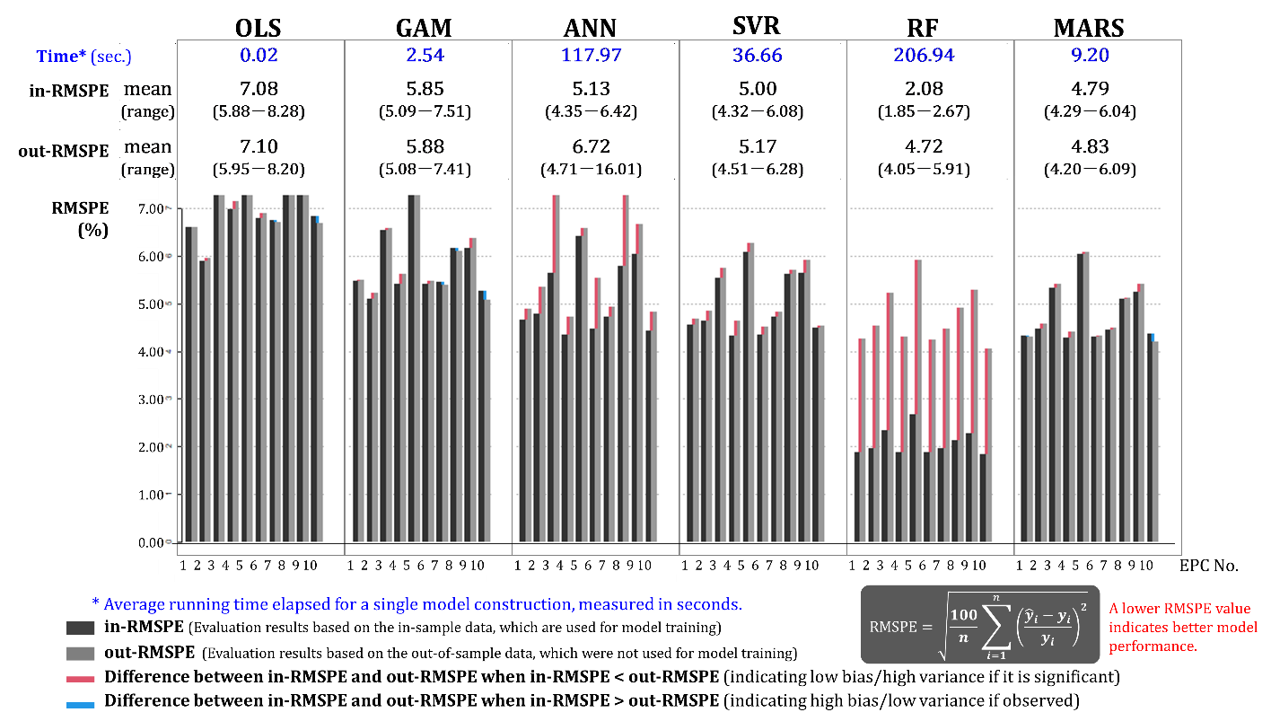
Fig. D.1. Performance of six different algorithms evaluated by RMSPE.

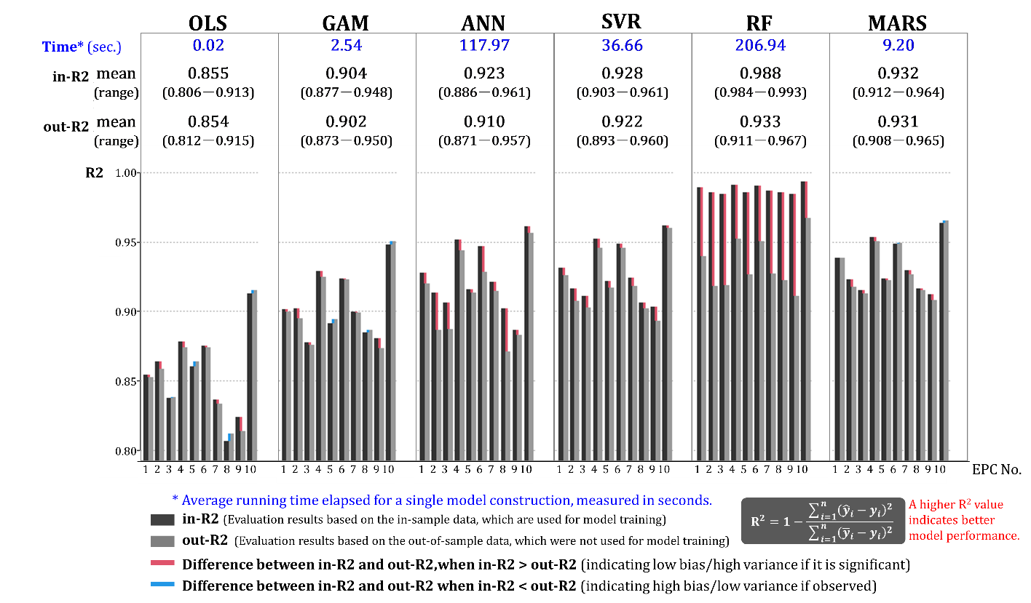
Fig. D.2. Performance of six different algorithms evaluated by R².

Appendix E: The MARS model and the model-building process
A summary of the MARS model and the model-building process is provided in this Appendix. Please see Friedman (1991), Shimokawa et al. (2013), and Milborrow (2021) for more detailed explanations.

The MARS model
In this study, the goal of the model building was to model the dependence of electricity demand (response variable $y$) on multiple factors, which were defined as the predictor variables ($x_{1},⋯,x_{P})$, given the dataset $L={\left\{{y_{n},x}_{1n},⋯,x_{Pn}\right\}}_{n =1}^{N}$. N is the number of observations $n$ and P is the number of predictor variables. The system that generated the dataset was assumed to be described by

$y=f(x_{1},⋯,x_{P} )+ε$ .

Where $ε$ is error term. The aim of regression analysis is to use the dataset $L$ to construct a function $\hat{f}(x_{1},⋯,x_{P} )$ that can serve as a reasonable approximation to $f(x_{1},⋯,x_{P} )$. MARS builds $\hat{f}$ of the form

$${\hat{f}}_{MARS}(x)={\hat{β}}_{0}+\sum_{m=1}^{M}{{\hat{β}}_{m}H_{m}(x)}$$

$$H_{m}(x)=\prod_{k=1}^{K_{m}}{{\left[s_{(k,m)}(x_{p(k,m)}-c_{p(k,m)})\right]}^{+}}$$

where ${\hat{β}}_{0}$ is the intercept, $H_{m}\left(x\right)$ is the basis function, ${\hat{β}}_{m}$ is the coefficient of $H_{m}(x)$, M is the number of the basis function, $K_{m}$ is the degree of interaction, ${\left[a\right]}^{+}( also represented by max\left(0,a\right))$means the positive part of $a$, $p(k,m)$ is the index for the variable of basis function $m$ with k-variable interactions, $c_{(k,m)}$ is a constant known as the “knot” for the variable $(k,m)$, and $s_{(k,m)}$takes the value $+1$ or $-1$.

Model-building process
MARS constructs a model in three phases: the forward stepwise (Algorithm 1), the backward stepwise (Algorithm 2), and the best model selection. In the first phase (forward stepwise), MARS starts from the intercept term, which is the single basis function $H_{0}(x)=1$ Then, MARS adds two basis functions $H_{m}(x)$to reduce the sum of the squared estimate of errors (SSE). MARS finally generates a large model (usually overly fit) with a maximum number of terms based on the maximum number of basis functions ($M_{max⁡})$ and the maximum degree of interaction $({ K}_{max⁡})$, which are specified by the model user. In the second phase (backward stepwise), MARS removes each basis function $H_{m}(x)$one by one. The basis function $H_{m}(x)$ that contributes the least to the fitness of the model is removed prior to others. This removal procedure is repeated until only the constant basis function $H_{0}(x)$ remains. The metric denoted as the generalized cross validation (GCV) criterion (Craven and Wahba, 1978) is used for best model selection. The model that gives minimum GCV is selected as the best model.

-------------------------------------------------------------------------------------------------------
Algorithm 1. forward stepwise
-------------------------------------------------------------------------------------------------------
1: Initialize: $H_{0}(x)=1, M=1, {SSE}^{*}←∞$
2: while $M≤M_{max}$ do
3: for $p∉\left\{p\left(k,m\right)|≥k≥K_{m}\right\}$ do
4: for $c∈\left\{x_{pn}\right\}$ do
5: $g\left(x\right)={\hat{f}}_{MARS}^{\left(M\right)f}\left(x;b_{0}, ⋯, b_{M-1}\right)+b_{M}H_{m}\left(x\right){[-{(x}_{p}-c)]}^{+}+b_{M+1}H_{m}\left(x\right){[+(x_{p}-c)]}^{+}$
6: $SSE=\min_{\left\{b_{0}, ⋯,b_{M+1}\right\}}\sum_{n=1}^{N}{{\left\{y_{n}-g(x_{n})\right\}}^{2}}$
7: if $SSE<{SSE}^{*}$ then $\left(\hat{c},\hat{p},\hat{m}\right)=\left(c,p,m\right), { SSE}^{*}=SSE$
8: end if
9: end for
10: end for
11: $H_{m}\left(x\right)=H_{\hat{m}}\left(x\right){[-{(x}_{\hat{p}}-\hat{c})]}^{+}$, $H_{m+1}\left(x\right)=H_{\hat{m}}\left(x\right){[+{(x}_{\hat{p}}-\hat{c})]}^{+}$
12: $M→M+2$
13: end while
-------------------------------------------------------------------------------------------------------
-------------------------------------------------------------------------------------------------------
Algorithm 2. backward stepwise
-------------------------------------------------------------------------------------------------------
1: Initialize: $\tilde{M}=\left\{1, ⋯,M_{max}-1 \right\}$
2: for $M=M_{max}-1$ do 1
3: ${SSE}^{*}←∞$
4: for $l∈\tilde{M}$do
5: $M←\tilde{M}-\left\{l\right\}$
6: $g\left(x_{n}\right)←b_{0}+\sum_{m∈M}{b_{m}H_{m}(x)}$
7: $SSE←\min_{\left\{b_{0}, b_{m},m∈M\right\}}\sum_{n=1}^{N}{{\left\{y_{n}-g(x_{n})\right\}}^{2}}$
8: if $SSE<{SSE}^{*}$ then
9: $\hat{l}←l, { SSE}^{*}←SSE$
10: end if
11: end for
12: $\tilde{M}←\tilde{M}-\left\{\hat{l}\right\}$
13: end for
-------------------------------------------------------------------------------------------------------

References
Craven, P., Wahba, G., 1978. Smoothing noisy data with spline functions. Numer. Math. 31, 377–403. https://doi.org/10.1007/BF01404567
Friedman, J.H., 1991. Multivariate Adaptive Regression Splines. Ann. Stat. 19, 1–67. https://doi.org/10.1214/aos/1176347963
Milborrow, S., 2021. Notes on the earth package.
Shimokawa, T., Kin, M., Sugimoto, T., Goto, M., 2013. Tree structured analysis: Jumoku kōzō sekkinhō (in Japanese), R de manabu dēta saiensu, 9. Kyōritsu Shuppan.

Appendix F: Observed and predicted hourly electricity demand
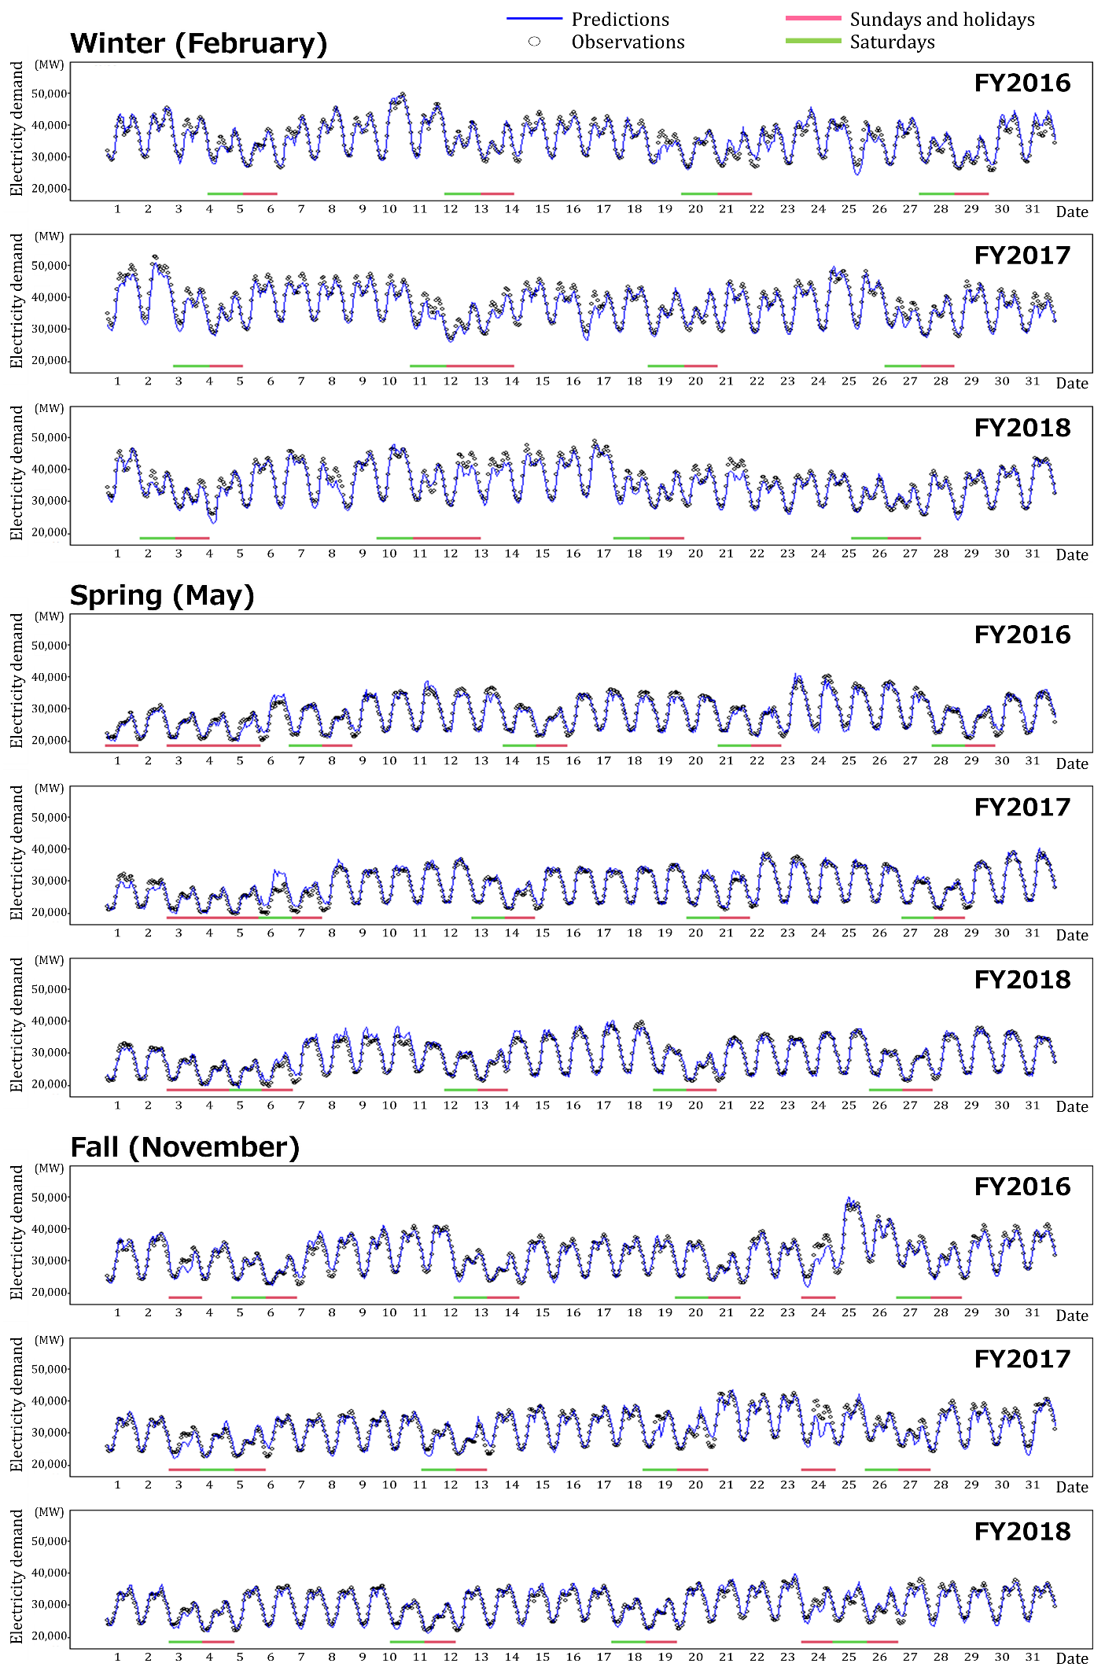
Fig. F.1. Observed and predicted hourly electricity demand. The results for other seasons, winterer (February), spring (May), and fall (November), are shown as examples. The horizontal axis shows the hours, and the vertical axis shows the electricity demand. The hourly predictions (blue line) agree well with the observations (black dots) along the time sequence, even during consecutive holidays.

Appendix G: Results of cross-fiscal year validation
Table G.1. Cross-fiscal year validation results (RMSPE).
 | Test data | FY2016 | FY2017 | FY2018 |  | a. Maximum  out-RMSPE | b. in-RMSPE | Deterioration
EPC | Training data |  |  |  |  |  |  | (a -b)
1.Hokkaido | FY2016 | 3.71 | 4.91 | 5.09 |  | 5.09 | 3.71 | 1.38
 | FY2017 | 5.01 | 3.97 | 4.88 |  | 5.01 | 3.97 | 1.03
 | FY2018 | 10.15 | 4.74 | 3.88 |  | 10.15 | 3.88 | 6.27
2.Tohoku | FY2016 | 4.21 | 5.31 | 4.81 |  | 5.31 | 4.21 | 1.10
 | FY2017 | 4.90 | 4.08 | 4.73 |  | 4.90 | 4.08 | 0.82
 | FY2018 | 4.93 | 4.97 | 3.96 |  | 4.97 | 3.96 | 1.01
3.Hokuriku | FY2016 | 5.05 | 6.60 | 6.88 |  | 6.88 | 5.05 | 1.84
 | FY2017 | 5.96 | 4.74 | 5.65 |  | 5.96 | 4.74 | 1.22
 | FY2018 | 6.22 | 5.65 | 4.55 |  | 6.22 | 4.55 | 1.66
4.Tokyo | FY2016 | 3.81 | 4.59 | 5.42 |  | 5.42 | 3.81 | 1.62
 | FY2017 | 4.65 | 3.78 | 4.68 |  | 4.68 | 3.78 | 0.90
 | FY2018 | 5.06 | 4.88 | 3.69 |  | 5.06 | 3.69 | 1.37
5.Chubu | FY2016 | 5.37 | 6.72 | 8.48 |  | 8.48 | 5.37 | 3.11
 | FY2017 | 6.68 | 5.59 | 7.29 |  | 7.29 | 5.59 | 1.70
 | FY2018 | 7.30 | 7.06 | 5.49 |  | 7.30 | 5.49 | 1.81
6.Kansai | FY2016 | 3.76 | 4.61 | 5.66 |  | 5.66 | 3.76 | 1.90
 | FY2017 | 4.45 | 3.72 | 5.03 |  | 5.03 | 3.72 | 1.32
 | FY2018 | 4.84 | 5.15 | 3.86 |  | 5.15 | 3.86 | 1.29
7.Chugoku | FY2016 | 3.54 | 5.20 | 5.33 |  | 5.33 | 3.54 | 1.79
 | FY2017 | 4.57 | 3.98 | 4.99 |  | 4.99 | 3.98 | 1.02
 | FY2018 | 4.58 | 5.80 | 3.87 |  | 5.80 | 3.87 | 1.93
8.Shikoku | FY2016 | 4.20 | 5.34 | 6.01 |  | 6.01 | 4.20 | 1.81
 | FY2017 | 4.97 | 4.54 | 6.05 |  | 6.05 | 4.54 | 1.50
 | FY2018 | 5.46 | 6.36 | 4.23 |  | 6.36 | 4.23 | 2.12
9.Kyushu | FY2016 | 5.74 | 5.88 | 5.42 |  | 5.88 | 5.74 | 0.15
 | FY2017 | 7.06 | 4.57 | 5.79 |  | 7.06 | 4.57 | 2.50
 | FY2018 | 7.42 | 6.65 | 3.95 |  | 7.42 | 3.95 | 3.47
10.Okinawa | FY2016 | 3.76 | 4.41 | 5.99 |  | 5.99 | 3.76 | 2.23
 | FY2017 | 4.79 | 3.35 | 5.82 |  | 5.82 | 3.35 | 2.47
 | FY2018 | 5.06 | 4.93 | 3.55 |  | 5.06 | 3.55 | 1.50

Table G.2. Cross-fiscal year validation results (R²).
 | Test data | FY2016 | FY2017 | FY2018 |  | a. Minimum  out-R2 | b. in-R2 | Deterioration
EPC | Training data |  |  |  |  |  |  | (b - a)
1.Hokkaido | FY2016 | 0.950 | 0.927 | 0.920 |  | 0.920 | 0.950 | 0.031
 | FY2017 | 0.909 | 0.951 | 0.914 |  | 0.909 | 0.951 | 0.042
 | FY2018 | 0.653 | 0.930 | 0.951 |  | 0.653 | 0.951 | 0.299
2.Tohoku | FY2016 | 0.929 | 0.891 | 0.899 |  | 0.891 | 0.929 | 0.039
 | FY2017 | 0.904 | 0.941 | 0.906 |  | 0.904 | 0.941 | 0.037
 | FY2018 | 0.909 | 0.911 | 0.935 |  | 0.909 | 0.935 | 0.026
3.Hokuriku | FY2016 | 0.924 | 0.882 | 0.844 |  | 0.844 | 0.924 | 0.080
 | FY2017 | 0.907 | 0.939 | 0.897 |  | 0.897 | 0.939 | 0.042
 | FY2018 | 0.893 | 0.910 | 0.930 |  | 0.893 | 0.930 | 0.037
4.Tokyo | FY2016 | 0.960 | 0.945 | 0.922 |  | 0.922 | 0.960 | 0.038
 | FY2017 | 0.945 | 0.964 | 0.946 |  | 0.945 | 0.964 | 0.019
 | FY2018 | 0.941 | 0.942 | 0.967 |  | 0.941 | 0.967 | 0.026
5.Chubu | FY2016 | 0.940 | 0.905 | 0.859 |  | 0.859 | 0.940 | 0.081
 | FY2017 | 0.912 | 0.935 | 0.894 |  | 0.894 | 0.935 | 0.041
 | FY2018 | 0.904 | 0.898 | 0.939 |  | 0.898 | 0.939 | 0.042
6.Kansai | FY2016 | 0.958 | 0.942 | 0.914 |  | 0.914 | 0.958 | 0.045
 | FY2017 | 0.944 | 0.962 | 0.933 |  | 0.933 | 0.962 | 0.029
 | FY2018 | 0.934 | 0.925 | 0.961 |  | 0.925 | 0.961 | 0.036
7.Chugoku | FY2016 | 0.945 | 0.929 | 0.903 |  | 0.903 | 0.945 | 0.042
 | FY2017 | 0.923 | 0.951 | 0.907 |  | 0.907 | 0.951 | 0.043
 | FY2018 | 0.909 | 0.876 | 0.942 |  | 0.876 | 0.942 | 0.066
8.Shikoku | FY2016 | 0.937 | 0.916 | 0.906 |  | 0.906 | 0.937 | 0.032
 | FY2017 | 0.914 | 0.939 | 0.903 |  | 0.903 | 0.939 | 0.036
 | FY2018 | 0.906 | 0.878 | 0.940 |  | 0.878 | 0.940 | 0.062
9.Kyushu | FY2016 | 0.903 | 0.904 | 0.901 |  | 0.901 | 0.903 | 0.001
 | FY2017 | 0.857 | 0.941 | 0.881 |  | 0.857 | 0.941 | 0.083
 | FY2018 | 0.858 | 0.873 | 0.943 |  | 0.858 | 0.943 | 0.085
10.Okinawa | FY2016 | 0.970 | 0.966 | 0.937 |  | 0.937 | 0.970 | 0.033
 | FY2017 | 0.958 | 0.980 | 0.947 |  | 0.947 | 0.980 | 0.033
 | FY2018 | 0.953 | 0.955 | 0.973 |  | 0.953 | 0.973 | 0.020

Appendix H: Hourly simulation results for all regions and algorithms
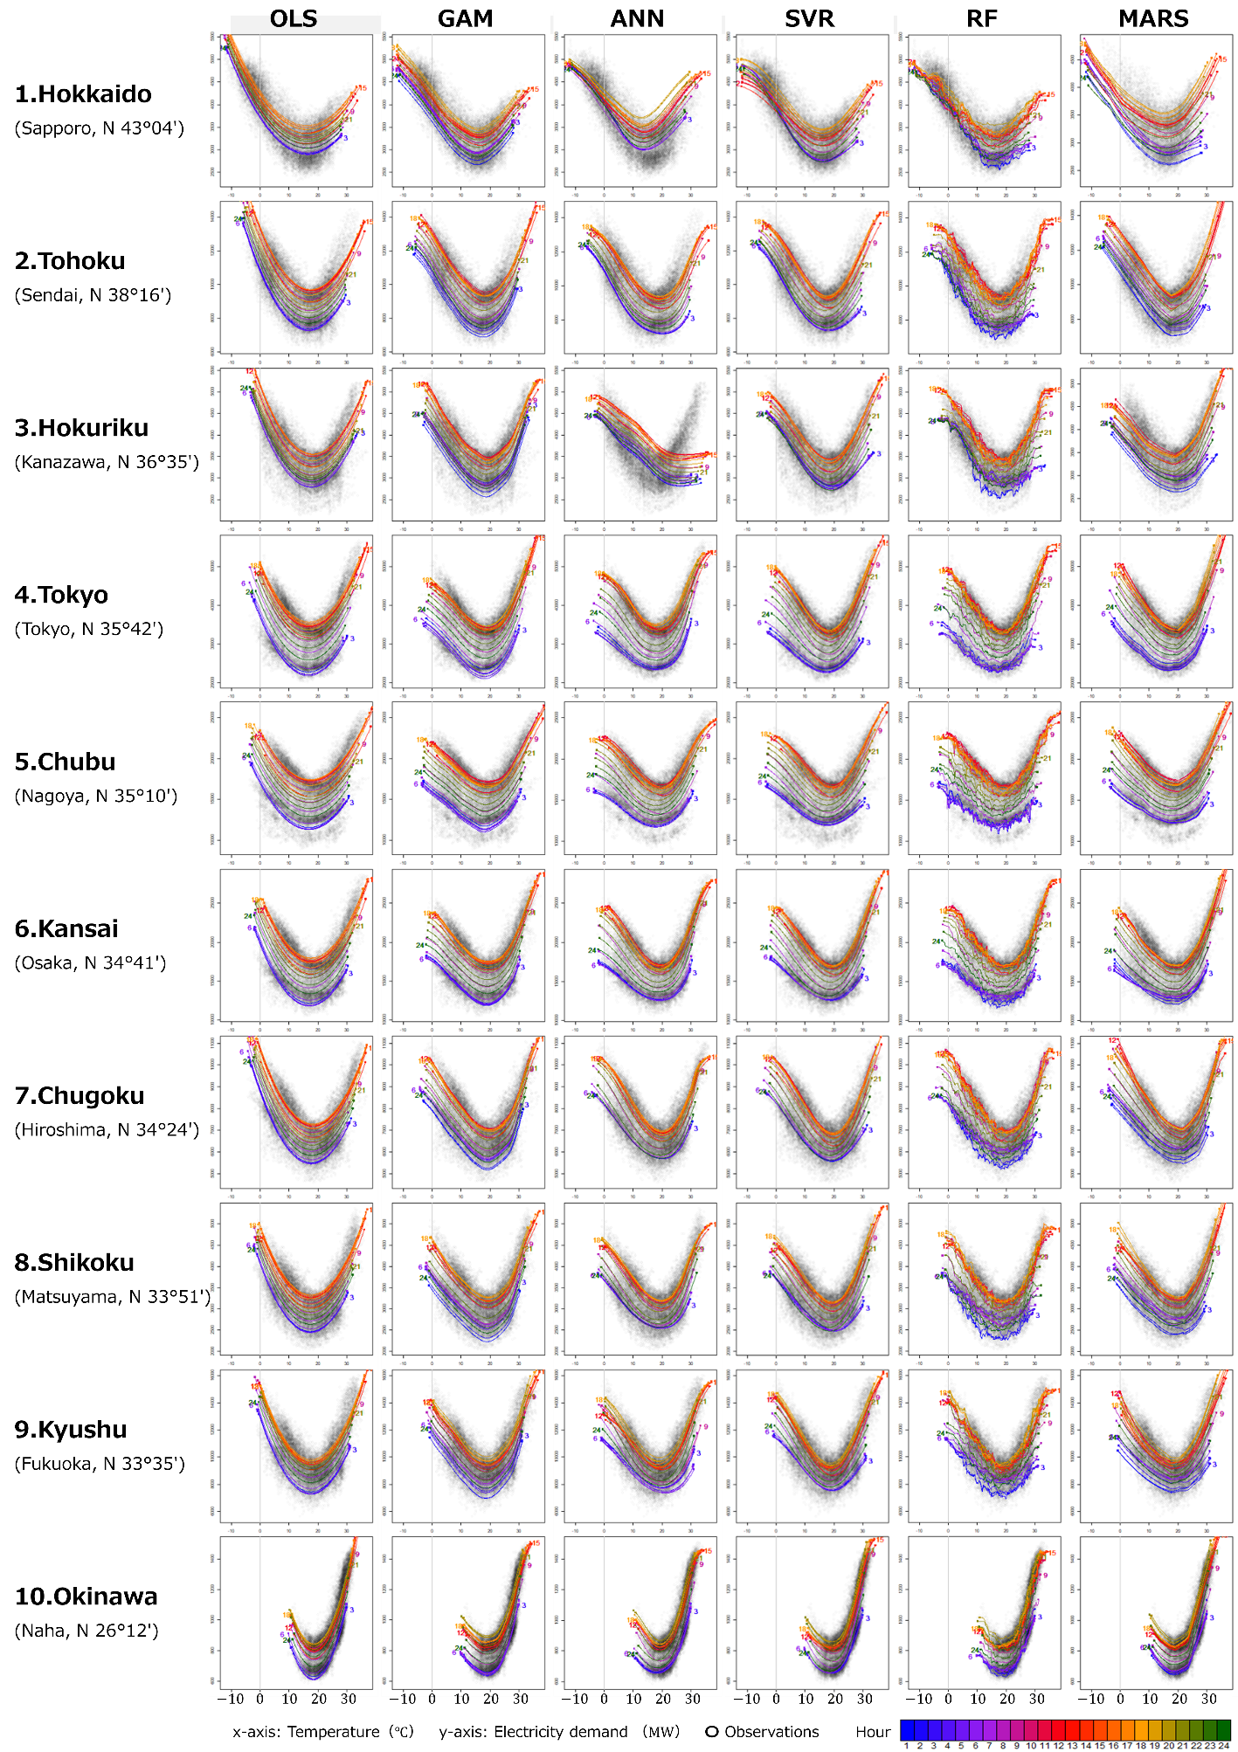
Fig. H.1. Hourly simulation results for the six algorithms for all regions.

Appendix I: Hourly changes in the BPT
Fig. I.1 shows hourly changes in the BPT in the 10 regions. The trends in Tokyo are similar to those in Chubu, Kansai, Chugoku, Shikoku, and Okinawa. The BPTs in other regions (Hokkaido, Tohoku, Hokuriku, and Kyushu) did not show the same trend because their TRFs were U-shaped rather than V-shaped. The presence of the flat section in the TRFs (i.e., a comfort zone) made it difficult to determine an explicit value for BPT.

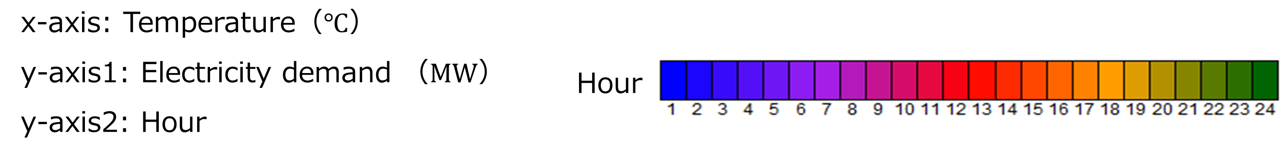
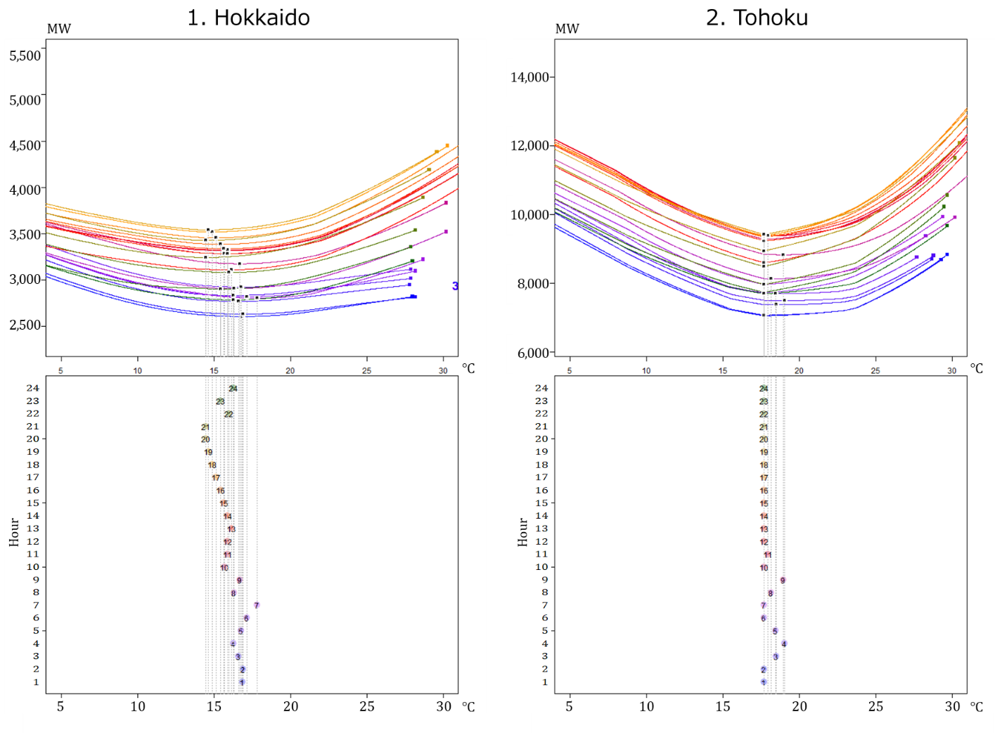
Fig. I.1. Hourly changes in BPT.

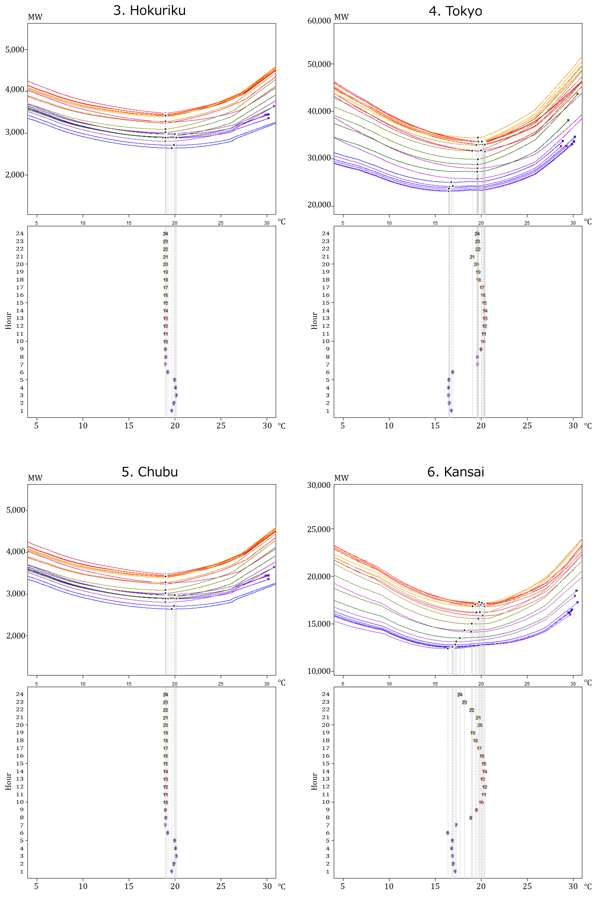
Fig. I.1. Hourly changes in BPT (continued).

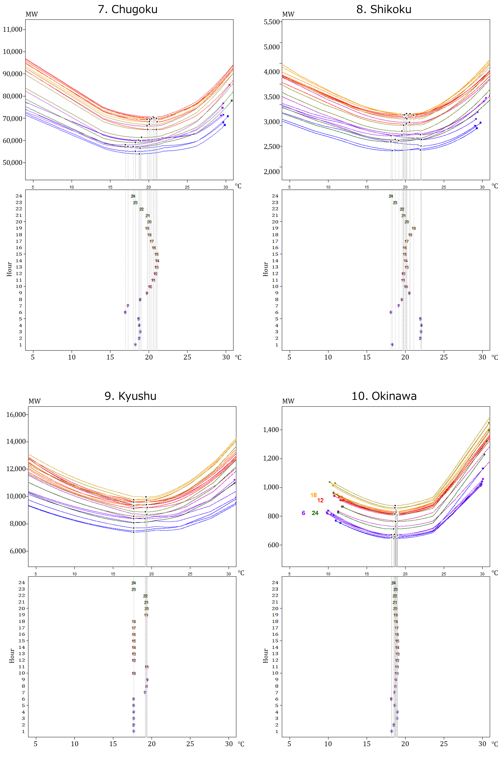

Fig. I.1. Hourly changes in BPT (continued).

Appendix J: Seasonal impacts that cannot be explained by meteorological factors.
Fig. J.1 shows the impacts of the monthly dummy variables that represent seasonal impacts that cannot be explained by meteorological factors. The simulation settings are presented in Table 6.
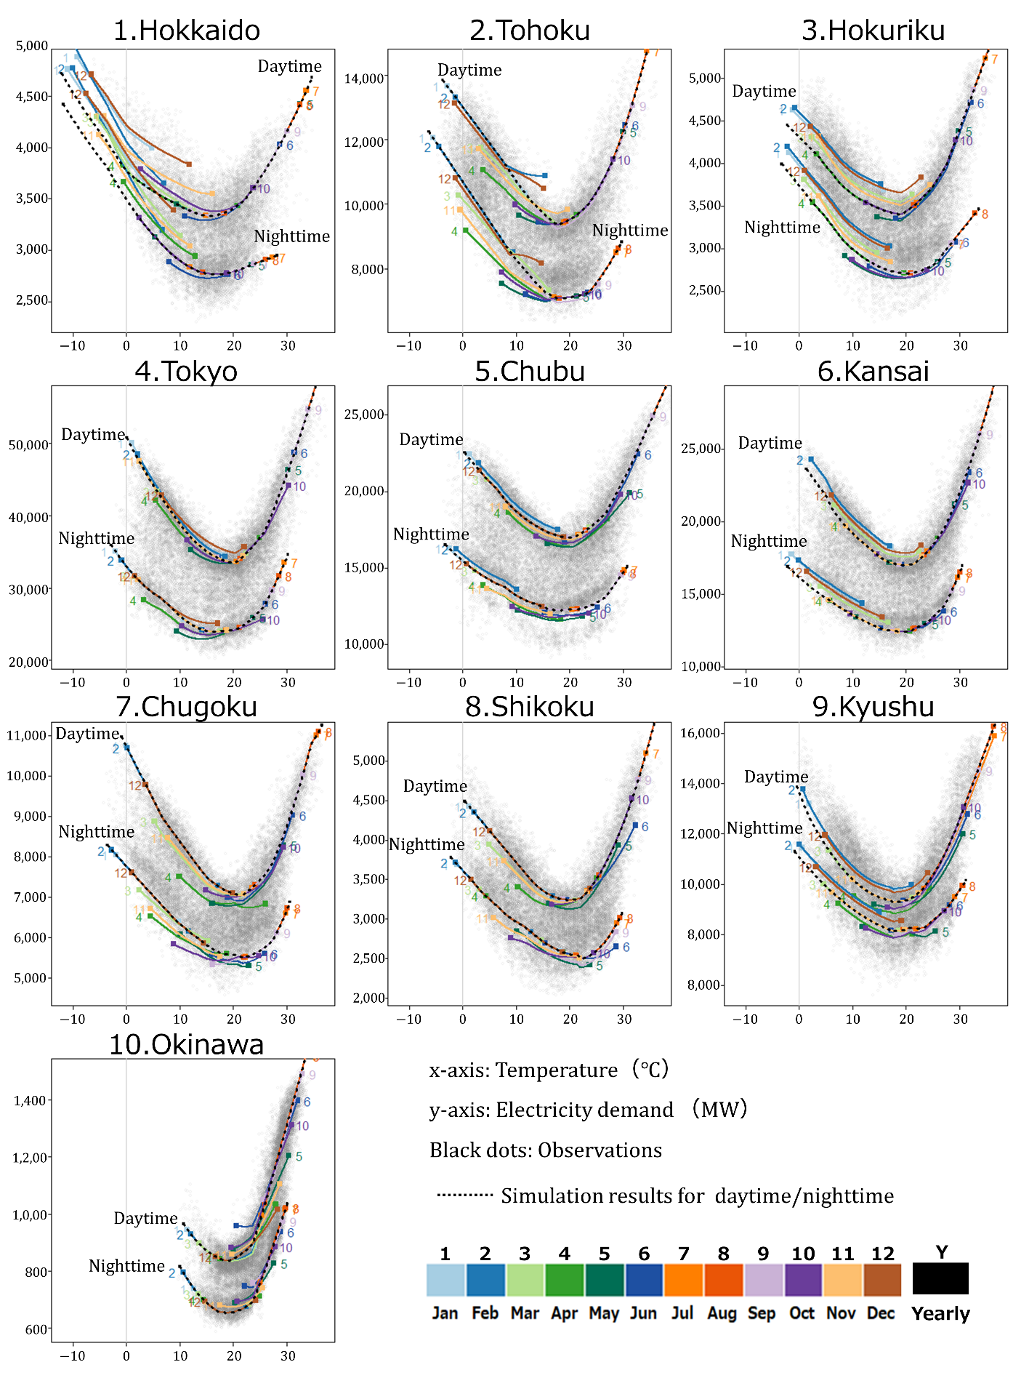
Fig. J.1. The results of monthly impact simulation. The simulation settings are listed in S3 in Table 6. The difference between simulation results for daytime and nighttime (S2, dot-line) and the monthly impact simulation result for each month (S3, colored lines) indicate existing seasonal impacts that cannot be explained by meteorological factors.

Appendix K: Daytime and nighttime TRFs
Fig. K.1 shows generation and approximation process of TRFs for all regions. Table K.1 presents the acquired parameters of the piecewise linear functions that approximate the flexible daytime/nighttime TRFs.

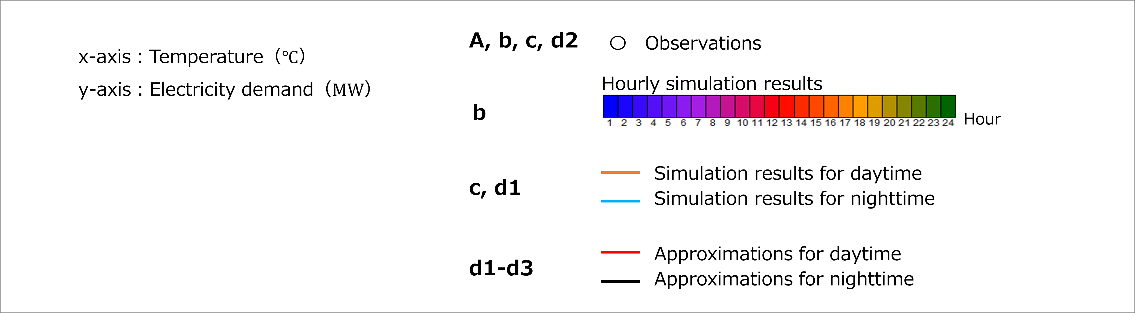
Legends for Fig. K.1.

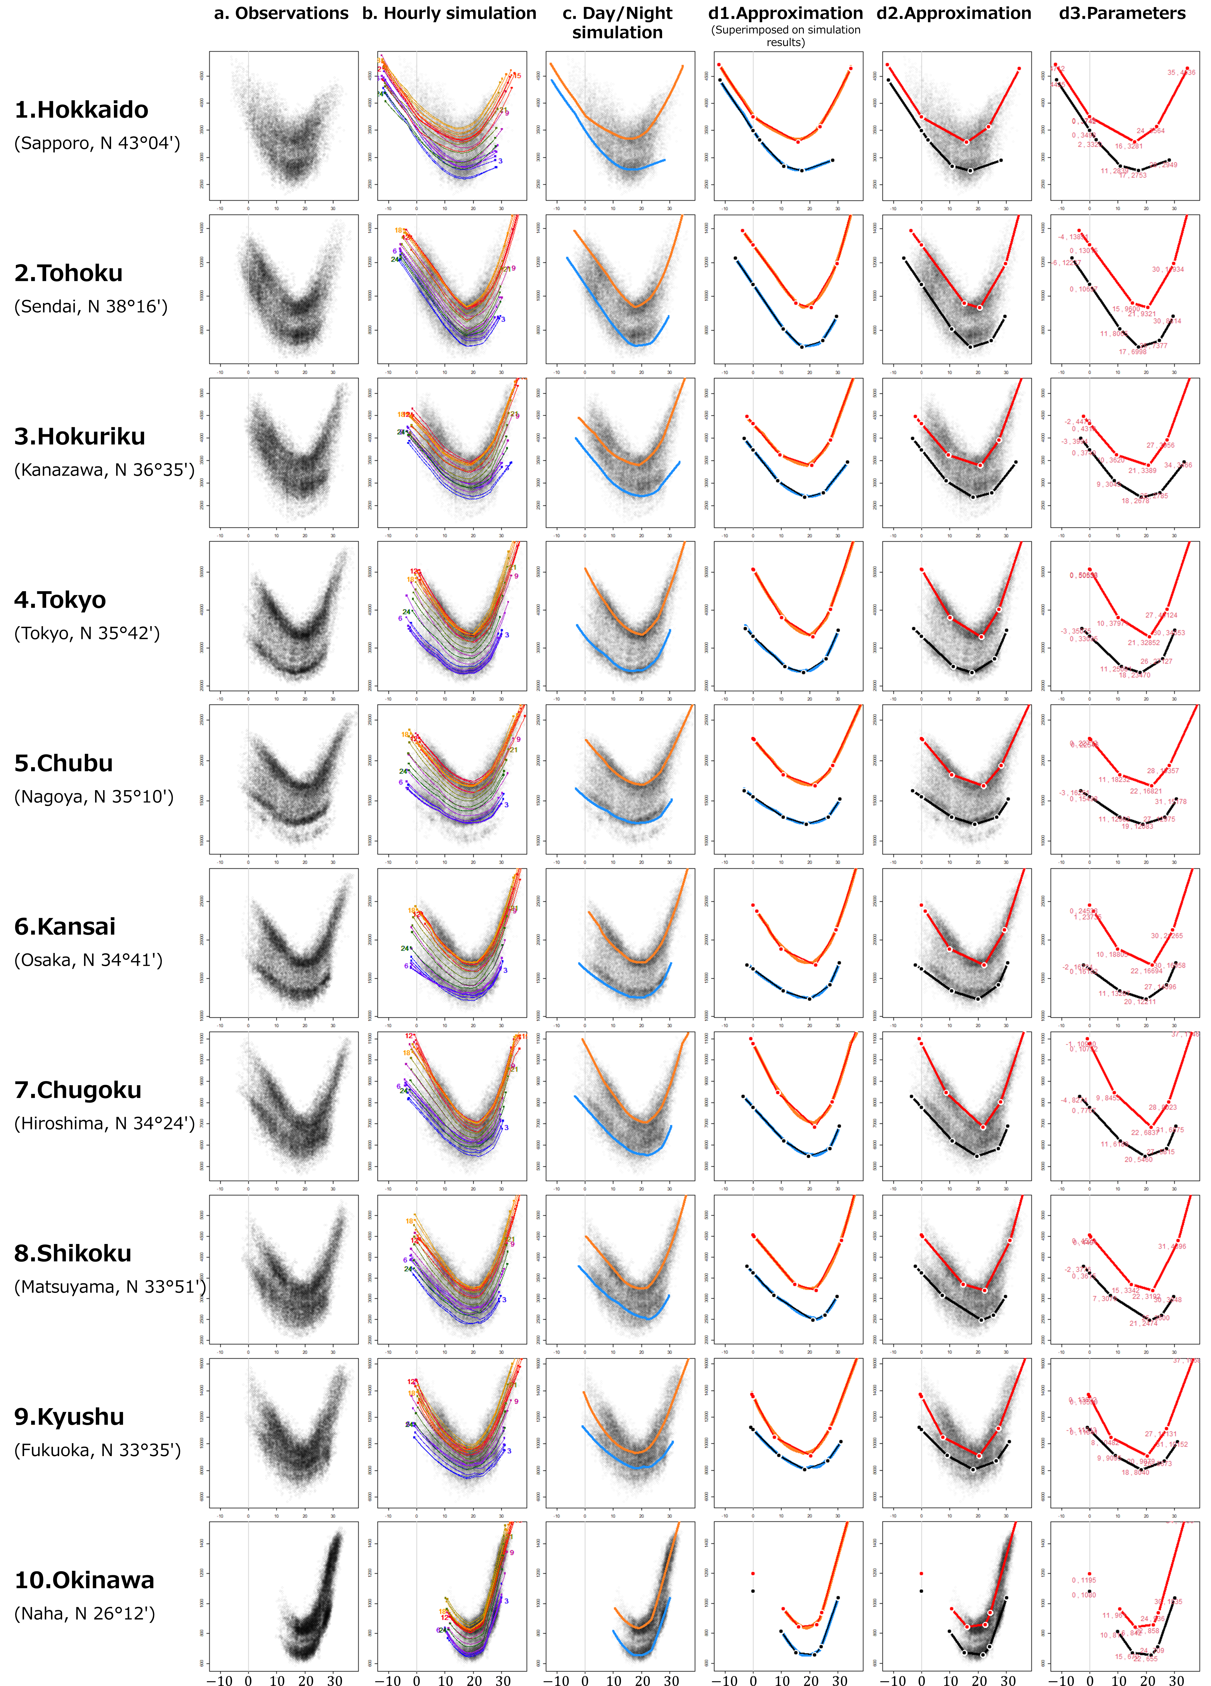
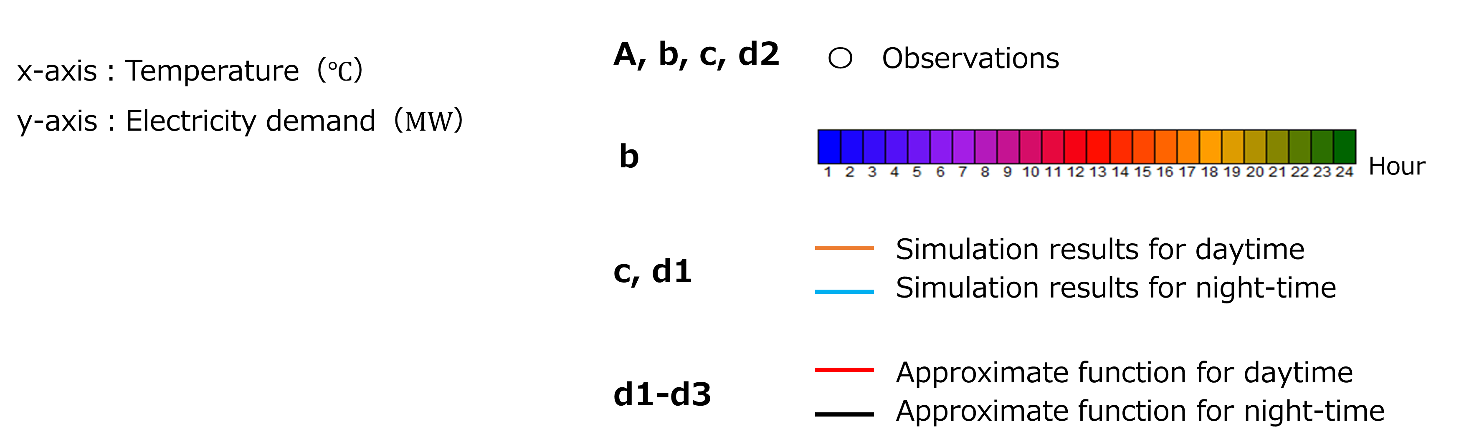
Fig. K.1. Determination and approximation process of TRFs.
(a) Observed electricity demand. (b) Hourly TRFs based on S1 in Table 6. (c) Daytime and nighttime TRFs based on S2 in Table 6. (d1) Approximated TRFs superimposed on the simulated daytime/ nighttime TRFs. (d2) Approximated TRFs superimposed on observations. (d3) Approximated TRFs with coordinates of the breakpoints.
Table K.1. Parameters for the piecewise linear functions.
 |  |  | Daytime |  |  | Nighttime
 |  |  | Coordinates of the breakpoints |  | Coefficient | Coordinates of the breakpoints |  | Coefficient
EPCs |  | No. of breakpoints | x  TEMP (℃) | y  Electricity  demand |  | x  TEMP (℃) | y  Electricity  demand
1 | Hokkaido | 1 | -12.1 | 4,712 | -80 | -11.8 | 4,425 | -79
 |  | 2 | 0.1 | 3,742 | -29 | 2.3 | 3,320 | -56
 |  | 3 | 16.0 | 3,281 | 37 | 10.9 | 2,839 | -13
 |  | 4 | 23.8 | 3,564 | 98 | 17.4 | 2,753 | 18
 |  | 5 | 34.7 | 4,636 | ― | 28.2 | 2,949 | ―
2 | Tohoku | 1 | -3.7 | 13,851 | -226 | -6.3 | 12,237 | -244
 |  | 2 | 15.1 | 9,600 | -51 | 10.8 | 8,065 | -162
 |  | 3 | 20.6 | 9,321 | 283 | 17.4 | 6,998 | 52
 |  | 4 | 29.9 | 11,934 | 623 | 24.7 | 7,377 | 287
 |  | 5 | 36.2 | 15,877 | ― | 29.7 | 8,814 | ―
3 | Hokuriku | 1 | -2.2 | 4,479 | -73 | -3.2 | 3,994 | -79
 |  | 2 | 9.5 | 3,620 | -20 | 8.8 | 3,045 | -38
 |  | 3 | 20.9 | 3,389 | 87 | 18.4 | 2,678 | 16
 |  | 4 | 27.4 | 3,956 | 172 | 25.0 | 2,785 | 79
 |  | 5 | 36.6 | 5,538 | ― | 33.6 | 3,466 | ―
4 | Tokyo | 1 | 0.0 | 50,658 | -1251 | -2.8 | 35,075 | -707
 |  | 2 | 10.1 | 37,971 | -464 | 11.3 | 25,081 | -242
 |  | 3 | 21.2 | 32,852 | 1165 | 18.0 | 23,470 | 465
 |  | 4 | 27.4 | 40,124 | 2233 | 25.9 | 27,127 | 1730
 |  | 5 | 37.1 | 61,735 | ― | 30.2 | 34,653 | ―
5 | Chubu | 1 | 0.4 | 22,546 | -418 | 0.0 | 15,498 | -236
 |  | 2 | 10.7 | 18,232 | -124 | 10.7 | 12,982 | -109
 |  | 3 | 22.1 | 16,821 | 414 | 18.9 | 12,083 | 114
 |  | 4 | 28.2 | 19,357 | 764 | 26.7 | 12,975 | 537
 |  | 5 | 40.2 | 28,528 | ― | 30.8 | 15,178 | ―
6 | Kansai | 1 | 1.4 | 23,735 | -573 | 0.0 | 16,162 | -267
 |  | 2 | 10.0 | 18,805 | -173 | 10.8 | 13,287 | -116
 |  | 3 | 22.2 | 16,694 | 624 | 20.0 | 12,211 | 262
 |  | 4 | 29.5 | 21,265 | 1164 | 27.2 | 14,096 | 865
 |  | 5 | 37.5 | 30,579 | ― | 30.5 | 16,958 | ―
7 | Chugoku | 1 | -0.9 | 10,990 | -265 | -3.5 | 8,274 | -145
 |  | 2 | 8.7 | 8,453 | -122 | 10.9 | 6,189 | -84
 |  | 3 | 21.9 | 6,837 | 192 | 19.6 | 5,460 | 47
 |  | 4 | 28.1 | 8,023 | 402 | 27.2 | 5,815 | 315
 |  | 5 | 36.6 | 11,462 | ― | 30.6 | 6,875 | ―

Table K.1. Parameters for the piecewise linear functions (continued).
 |  |  | Daytime |  |  | Nighttime
 |  |  | Coordinates of the breakpoints |  | Coefficient | Coordinates of the breakpoints |  | Coefficient
EPCs |  | No. of breakpoints | x  TEMP (℃) | y  Electricity  demand |  | x  TEMP (℃) | y  Electricity  demand
8 | Shikoku | 1 | 0.0 | 4,523 | -80 | -2.2 | 3,776 | -73
 |  | 2 | 14.8 | 3,342 | -20 | 7.4 | 3,076 | -43
 |  | 3 | 22.3 | 3,192 | 132 | 21.3 | 2,474 | 30
 |  | 4 | 31.4 | 4,396 | 252 | 25.5 | 2,600 | 103
 |  | 5 | 37.2 | 5,849 | ― | 29.8 | 3,048 | ―
9 | Kyushu | 1 | -0.4 | 13,692 | -404 | -0.8 | 11,213 | -215
 |  | 2 | 7.5 | 10,482 | -109 | 9.1 | 9,095 | -114
 |  | 3 | 20.4 | 9,079 | 295 | 18.3 | 8,040 | 78
 |  | 4 | 27.3 | 11,131 | 564 | 26.4 | 8,673 | 307
 |  | 5 | 37.2 | 16,688 | ― | 31.2 | 10,152 | ―
10 | Okinawa | 1 | 10.7 | 961 | -22 | 10.0 | 811 | -27
 |  | 2 | 16.1 | 842 | 2 | 15.3 | 670 | -2
 |  | 3 | 22.5 | 858 | 41 | 21.9 | 655 | 24
 |  | 4 | 24.4 | 936 | 67 | 24.1 | 709 | 55
 |  | 5 | 34.1 | 1,590 | ― | 30.1 | 1,035 | ―

